Table S1. Tests of precision and accuracy of Mg isotope analyses
Sample | δ²⁶Mg | 2σ | δ²⁵Mg | 2σ | N
Isotope standards in this study
Cambridge 1 | -2.58 | 0.09 | -1.33 | 0.06 | 18
DSM3 | 0.00 | 0.10 | 0.01 | 0.05 | 18
Test solutions processed by the ion-exchange procedure
IAPSO seawater | -0.82 | 0.10 | -0.42 | 0.05 | 18
DST-2b | -0.29 | 0.08 | -0.14 | 0.05 | 16
BIR-1a | -0.34 | 0.04 | -0.19 | 0.06 | 2
Isotope compositions of standards in references
Cambridge 1 (Li et al., 2012) | -2.57 | 0.12 | -1.33 | 0.1 | 87
Cambridge 1 (An and Huang, 2014) | -2.597 | 0.042 | -1.343 | 0.036 | 49
Cambridge 1 (Teng et al., 2015) | -2.623 | 0.03 | -1.358 | 0.03 | ﹥20
DSM3 (Tipper et al., 2010) | 0 | 0.05 | 0 | 0.03 | 100
DSM3 (Li et al., 2012) | 0.02 | 0.13 | 0 | 0.09 | 109
IAPSO seawater (Hippler et al., 2009) | -0.8 | 0.05 | -0.42 | 0.02 | 10
IAPSO seawater (Teng et al., 2015) | -0.83 | 0.09 | -0.42 | 0.06 | ﹥20
Seawater (Ling et al., 2011) | -0.832 | 0.068 | -0.432 | 0.053 | 40
DST-2b (Bizzarro et al., 2011)) | -0.23 | 0.03 | -0.12 | 0.02 | 7
DST-2b (Teng et al., 2015) | -0.32 | 0.06 | -0.17 | 0.04 | ﹥20
BIR-1a (Opfergelt et al., 2012) | -0.27 | 0.33 | -0.18 | 0.18 | 14
BIR-1a (Shen et al., 2013) | -0.3 | 0.04 | -0.16 | 0.03 | 3

Reference
An, Y., and Huang, F., 2014, A review of Mg isotope analytical methods by MC-ICP-MS: Journal of Earth Science, v. 25, no. 5, p. 822-840.
Bizzarro, M., Paton, C., Larsen, K., Schiller, M., Trinquier, A., and Ulfbeck, D., 2011, High-precision Mg-isotope measurements of terrestrial and extraterrestrial material by HR-MC-ICPMS—implications for the relative and absolute Mg-isotope composition of the bulk silicate Earth: Journal of Analytical Atomic Spectrometry, v. 26, no. 3, p. 565.
Hippler, D., Buhl, D., Witbaard, R., Richter, D. K., and Immenhauser, A., 2009, Towards a better understanding of magnesium-isotope ratios from marine skeletal carbonates: Geochimica et Cosmochimica Acta, v. 73, no. 20, p. 6134-6146.
Li, W., Chakraborty, S., Beard, B. L., Romanek, C. S., and Johnson, C. M., 2012, Magnesium isotope fractionation during precipitation of inorganic calcite under laboratory conditions: Earth and Planetary Science Letters, v. 333-334, p. 304-316.
Ling, M. X., Sedaghatpour, F., Teng, F. Z., Hays, P. D., Strauss, J., and Sun, W., 2011, Homogeneous magnesium isotopic composition of seawater: an excellent geostandard for Mg isotope analysis: Rapid Commun Mass Spectrom, v. 25, no. 19, p. 2828-2836.
Opfergelt, S., Georg, R. B., Delvaux, B., Cabidoche, Y. M., Burton, K. W., and Halliday, A. N., 2012, Mechanisms of magnesium isotope fractionation in volcanic soil weathering sequences, Guadeloupe: Earth and Planetary Science Letters, v. 341-344, p. 176-185.
Shen, B., Wimpenny, J., Lee, C.-T. A., Tollstrup, D., and Yin, Q.-Z., 2013, Magnesium isotope systematics of endoskarns: Implications for wallrock reaction in magma chambers: Chemical Geology, v. 356, p. 209-214.
Teng, F.-Z., Li, W.-Y., Ke, S., Yang, W., Liu, S.-A., Sedaghatpour, F., Wang, S.-J., Huang, K.-J., Hu, Y., Ling, M.-X., Xiao, Y., Liu, X.-M., Li, X.-W., Gu, H.-O., Sio, C. K., Wallace, D. A., Su, B.-X., Zhao, L., Chamberlin, J., Harrington, M., and Brewer, A., 2015, Magnesium Isotopic Compositions of International Geological Reference Materials: Geostandards and Geoanalytical Research, v. 39, no. 3, p. 329-339.
Tipper, E. T., Gaillardet, J., Louvat, P., Capmas, F., and White, A. F., 2010, Mg isotope constraints on soil pore-fluid chemistry: Evidence from Santa Cruz, California: Geochimica et Cosmochimica Acta, v. 74, no. 14, p. 3883-3896.

Table S2-1. Mg isotope data for bulk dolostone in Penglaiba Formation (Bulk samples)
Core No. | Sam. No. | Depth/m | lithology | Mg isotope ratios
 |  |  |  | δ²⁶Mg/‰ | 2sd | δ²⁵Mg/‰ | 2sd | N
S88 | S88-18 | 6421.63 | dolostone composed by D1 dolomite | -2.07 | 0.04 | -1.05 | 0.02 | 2
S88 | S88-35 | 6486.13 | dolostone composed by D1 dolomite | -2.21 | 0.07 | -1.13 | 0.03 | 2
S88 | S88-19 | 6422.15 | dolostone composed by D2 and D3 dolomite | -2.01 | 0.09 | -1.03 | 0.02 | 2
S88 | S88-20 | 6425.45 | dolostone composed by D2 and D3 dolomite | -2.02 | 0.07 | -1.04 | 0.07 | 2
TS2 | TS2-13 | 6553.13 | dolostone composed by D1 dolomite | -2.03 | 0.03 | -1.06 | 0.09 | 2
TS2 | TS2-14 | 6554.38 | dolostone composed by D1 dolomite | -2.13 | 0.02 | -1.13 | 0.05 | 2
TS2 | TS2-7 | 6550.2 | dolostone composed by D2 dolomite | -2.11 | 0.07 | -1.08 | 0.01 | 2
TS2 | TS2-10 | 6551.65 | dolostone composed by D2 dolomite | -2.05 | 0.01 | -1.07 | 0.01 | 2
TS2 | TS2-11 | 6552.1 | dolostone composed by D2 dolomite | -2.16 | 0.04 | -1.11 | 0.06 | 2
TS2 | TS2-16 | 6692.57 | dolostone composed by D2 dolomite | -2.12 | 0.05 | -1.12 | 0 | 2
TS2 | TS2-17 | 6693.2 | dolostone composed by D2 dolomite | -2.19 | 0.02 | -1.15 | 0 | 2
TS2 | TS2-5 | 6693.5 | dolostone composed by D2 and D3 dolomite | -2.12 | 0.04 | -1.11 | 0.04 | 2
YB5 | YB5-12 | 6841.26 | dolostone composed D2 dolomite | -1.98 | 0.06 | -1.03 | 0.01 | 2
YB5 | YB5-4 | 6740.02 | dolostone composed by D2 and D3 dolomite | -2.11 | 0.08 | -1.09 | 0.01 | 2
YB5 | YB5-7 | 6741.4 | dolostone composed by D2 and D3 dolomite | -2.12 | 0.04 | -1.12 | 0 | 2
YB5 | YB5-2 | 6607.02 | dolostone composed by D3 dolomite | -2.08 | 0 | -1.08 | 0.02 | 2
YB5 | YB5-8 | 6839.53 | dolostone composed by D3 dolomite | -2.1 | 0.07 | -1.09 | 0.06 | 2
YB5 | YB5-11 | 6840.35 | dolostone composed by D3 dolomite | -1.98 | 0.05 | -1.02 | 0.01 | 2
YB5 | YB5-14 | 6842.68 | dolostone composed by D3 dolomite | -2.13 | 0.12 | -1.09 | 0.07 | 2
Aksu outcrop |  | AO 1-1* | decolourized dolomite (D3) | -1.97 | 0.11 | -0.99 | 0.01 | 2
 |  | AO 1-2 | matrix dolomite (D3) | -1.90 | 0.08 | -1.00 | 0.01 | 2
 |  | AO 2-1* | decolourized dolomite | -2.02 | 0.03 | -1.04 | 0.04 | 2
 |  | AO 2-2 | matrix dolomite (D3) | -1.91 | 0.05 | -0.99 | 0.08 | 2
 |  | AO 3-1* | decolourized dolomite | -2.00 | 0.05 | -1.04 | 0.01 | 2
 |  | AO 3-2 | matrix dolomite (D3) | -2.04 | 0.01 | -1.05 | 0.01 | 2
* Hydrothermal related dolomite

Table S2-2. Mg isotope data for different types of dolomite in dolostone (Micro drilling)
Core No. | Sam. No. | Depth/m | Drilling site | Mg isotope ratios
 |  |  |  | δ²⁶Mg/‰ | 2sd | δ²⁵Mg/‰ | 2sd | N
TS2 | TS2-8 | 6551.7 | matrix dolomite (D1) | -1.93 | 0.02 | -0.99 | 0.01 | 2
TS2 | TS2-8 | 6551.7 | matrix dolomite (D1) | -2.05 | 0.03 | -1.05 | 0.00 | 2
TS2 | TS2-8 | 6551.7 | CD dolomite* | -1.76 | 0.06 | -0.90 | 0.13 | 2
TS2 | TS2-8 | 6551.7 | CD dolomite* | -1.84 | 0.06 | -0.94 | 0.05 | 2
TS2 | TS2-9 | 6552.85 | D1 dolomite | -1.95 | 0.03 | -1.02 | 0.02 | 2
TS2 | TS2-9 | 6552.85 | D1 dolomite | -1.97 | 0.15 | -1.00 | 0.02 | 2
TS2 | TS2-9 | 6552.85 | D2 dolomite | -2.01 | 0.02 | -1.03 | 0.02 | 2
TS2 | TS2-9 | 6552.85 | D2 dolomite | -2.12 | 0.14 | -1.08 | 0.07 | 2
TS2 | TS2-16 | 6692.57 | CD dolomite* | -2.25 | 0.06 | -1.16 | 0.08 | 2
TS2 | TS2-16 | 6692.57 | CD dolomite* | -1.97 | 0.09 | -1.02 | 0.02 | 2
TS2 | TS2-16 | 6692.57 | CD dolomite* | -2.25 | 0.04 | -1.14 | 0.05 | 2
TS2 | TS2-16 | 6692.57 | matrix dolomite (D2) | -2.09 | 0.07 | -1.09 | 0.08 | 2
TS2 | TS2-16 | 6692.57 | matrix dolomite (D2) | -2.06 | 0.09 | -1.04 | 0.03 | 2
TS2 | TS2-16 | 6692.57 | matrix dolomite (D2) | -2.06 | 0.11 | -1.10 | 0.06 | 2
TS2 | TS2-17 | 6693.2 | D2 dolomite | -2.03 | 0.06 | -1.11 | 0.01 | 2
TS2 | TS2-17 | 6693.2 | D1 dolomite | -2.21 | 0.10 | -1.13 | 0.01 | 2
YB5 | YB5-14 | 6842.68 | LD dolomite* | -2.01 | 0.02 | -1.04 | 0.01 | 2
YB5 | YB5-14 | 6842.68 | LD dolomite* | -2.08 | 0.04 | -1.10 | 0.02 | 2
YB5 | YB5-14 | 6842.68 | LD dolomite* | -1.97 | 0.06 | -1.05 | 0.04 | 2
YB5 | YB5-14 | 6842.68 | matrix dolomite (D3) | -2.11 | 0.12 | -1.08 | 0.08 | 2
YB5 | YB5-8 | 6839.53 | LD dolomite* | -2.02 | 0.06 | -1.04 | 0.05 | 2
* Hydrothermal related dolomite

Table S3. XRD data for mineralogy of carbonate in Penglaiba Formation (Bulk samples)
Powder X-ray diffraction analysis of bulk sample powders was performed on a Rigaku Rapid II dual-source X-ray Diffractometer, using a rotating anode Mo target X-ray source (Mo Kα = 0.714Å) running at 40kV and 100mA. Intensities of (104) peaks for calcite and dolomite were obtained from the XRD spectrum using a PDXL software and the relative abundance of dolomite and calcite in bulk rocks was estimated from the intensities of the (104) peaks (Zevin, 1977).
Core No. | Sam. No. | Depth/m | lithology | Mineral component (wt, %)
 |  |  |  | Quartz | Calcite | Dolomite
S88 | S88-18 | 6421.63 | dolostone composed by D1 dolomite | / | / | 100
S88 | S88-35 | 6486.13 | dolostone composed by D1 dolomite | / | / | 100
S88 | S88-19 | 6422.15 | dolostone composed by D2 and D3 dolomite | 7 | / | 93
S88 | S88-20 | 6425.45 | dolostone composed by D2 and D3 dolomite | / | / | 100
S88 | S88-9 | 6367.01 | limestone | 4 | 92 | 4
S88 | S88-10 | 6370.2 | limestone | 3 | 93 | 4
S88 | S88-11 | 6370.5 | limestone | 2 | 78 | 20
S88 | S88-12 | 6370.8 | limestone | 4 | 68 | 28
S88 | S88-14 | 6371.8 | limestone | 3 | 97 | /
TS2 | TS2-13 | 6553.13 | dolostone composed by D1 dolomite | 5 | / | 95
TS2 | TS2-14 | 6554.38 | dolostone composed by D1 dolomite | 5 | / | 95
TS2 | TS2-7 | 6550.2 | dolostone composed by D2 dolomite | 2 | / | 98
TS2 | TS2-10 | 6551.65 | dolostone composed by D2 dolomite | 4 | / | 96
TS2 | TS2-11 | 6552.1 | dolostone composed by D2 dolomite | 1 | / | 99
TS2 | TS2-16 | 6692.57 | dolostone composed by D2 dolomite |  | / | 100
TS2 | TS2-17 | 6693.2 | dolostone composed by D2 dolomite | 3 | / | 97
TS2 | TS2-5 | 6693.5 | dolostone composed by D2 and D3 dolomite | / | / | 100
YB5 | YB5-12 | 6841.26 | dolostone composed D2 dolomite | 5 | / | 95
YB5 | YB5-4 | 6740.02 | dolostone composed by D2 and D3 dolomite | 2 | / | 98
YB5 | YB5-7 | 6741.4 | dolostone composed by D2 and D3 dolomite | / | / | 100
YB5 | YB5-2 | 6607.02 | dolostone composed by D3 dolomite | 13 | / | 87
YB5 | YB5-8 | 6839.53 | dolostone composed by D3 dolomite | 14 | / | 86
YB5 | YB5-11 | 6840.35 | dolostone composed by D3 dolomite | 3 | / | 97
YB5 | YB5-14 | 6842.68 | dolostone composed by D3 dolomite | 63 | / | 37
Zevin, L. S. (1977). A method of quantitative phase analysis without standards. Journal of Applied Crystallography 10, 147-150.

Table S4-1. C, O isotope data of carbonate in Penglaiba Formation (bulk samples)
Core No. | Sam. No. | Depth/m | lithology | δ¹³C_{V-PDB} (‰) | δ¹⁸O _{V-PDB} (‰)
S88 | S88-9 | 6367.01 | limestone | -2.1 | -9.2
S88 | S88-10 | 6370.2 | limestone | -1.9 | -8.5
S88 | S88-11 | 6370.5 | limestone | -1.8 | -8.9
S88 | S88-12 | 6370.8 | limestone | -1.8 | -8.9
S88 | S88-14 | 6371.8 | limestone | -1.5 | -8.6
Aksu Outcrop | AO1-1* |  | decolourized dolomite (D3) | -1.0 | -6.3
Aksu Outcrop | AO 1-2 |  | matrix dolomite (D3) | -0.6 | -6.1
Aksu Outcrop | AO 2-1* |  | decolourized dolomite | -3.0 | -8.3
Aksu Outcrop | AO 2-2 |  | matrix dolomite (D3) | -0.2 | -7.2
Aksu Outcrop | AO 3-1* |  | decolourized dolomite | -3.0 | -8.7
Aksu Outcrop | AO 3-2 |  | matrix dolomite (D3) | -0.5 | -7.5
* Hydrothermal related dolomite

Table S4-2. C, O isotope data of different types of dolomite in dolostone (Micro drilling)
Core No. | Sam. No. | Depth/m | Drilling site | δ¹³C_{V-PDB} (‰) | δ¹⁸O _{V-PDB} (‰)
S88 | S88-18 | 6421.63 | D1 dolomite | -1.9 | -6.8
S88 | S88-35 | 6486.13 | D1 dolomite | -2 | -4.9
TS2 | TS2-7 | 6550.2 | D1 dolomite | -1.9 | -7.1
TS2 | TS2-7 | 6550.2 | D2 dolomite | -1.7 | -7.9
TS2 | TS2-10 | 6553.65 | D1 dolomite | -1.2 | -6.6
TS2 | TS2-10 | 6553.65 | D2 dolomite | -1.6 | -7.3
TS2 | TS2-9 | 6552.85 | D1 dolomite | -1.2 | -5
TS2 | TS2-9 | 6552.85 | D1 dolomite | -1.3 | -5.9
TS2 | TS2-9 | 6552.85 | D2 dolomite | -1.2 | -6.5
TS2 | TS2-9 | 6552.85 | D2 dolomite | -1 | -6.6
TS2 | TS2-17 | 6693.2 | D1 dolomite | -1.3 | -7.2
TS2 | TS2-17 | 6693.2 | D2 dolomite | -1.6 | -7.5
TS2 | TS2-16 | 6692.57 | CD dolomite* | -2 | -8
TS2 | TS2-16 | 6692.57 | CD dolomite* | -2.5 | -8.6
TS2 | TS2-16 | 6692.57 | CD dolomite* | -2.1 | -8.5
TS2 | TS2-16 | 6692.57 | matrix dolomite (D2) | -1.8 | -7.8
TS2 | TS2-16 | 6692.57 | matrix dolomite (D2) | -1.8 | -7.6
TS2 | TS2-16 | 6692.57 | matrix dolomite (D2) | -1.9 | -7.8
TS2 | TS2-8 | 6551.7 | CD dolomite* | -2.1 | -8.2
TS2 | TS2-8 | 6551.7 | CD dolomite* | -1.8 | -7
TS2 | TS2-8 | 6551.7 | matrix dolomite (D1) | -1.4 | -5.9
TS2 | TS2-8 | 6551.7 | matrix dolomite (D1) | -1.4 | -5.6
TS2 | TS2-15 | 6692 | D1 dolomite | -1.3 | -6.7
YB5 | YB5-14 | 6842.68 | LD dolomite* | -1.2 | -7.6
YB5 | YB5-14 | 6842.68 | LD dolomite* | -1.1 | -7.5
YB5 | YB5-14 | 6842.68 | LD dolomite* | -1.5 | -7.4
YB5 | YB5-14 | 6842.68 | matrix dolomite (D3) | -0.3 | -7.2
YB5 | YB5-8 | 6839.53 | LD dolomite* | -1 | -8.2
YB5 | YB5-8 | 6839.53 | LD dolomite* | -1.1 | -7.1
YB5 | YB5-8 | 6839.53 | matrix dolomite (D3) | -0.8 | -7.1
* Hydrothermal related dolomite

Table S5. Trace element contents of carbonates (bulk samples)
Sam. No. | lithology | trace element contents/ppm
Sam. No. | lithology | V | Mn | Co | Ni | Cu | Zn | Ba | La | Ce | Pr | Nd | Sm | Eu | Gd | Tb | Dy | Ho | Er | Tm | Yb | Lu
S88-18 | dolostone composed by D1 dolomite | 10.61 | 99.18 | 1.93 | 19.28 | 3.83 | 6.73 | 8.01 | 2.4 | 4.6 | 0.59 | 2.26 | 0.41 | 0.07 | 0.37 | 0.06 | 0.31 | 0.06 | 0.16 | 0.03 | 0.16 | 0.02
S88-35 | dolostone composed by D1 dolomite | 7.37 | 187.04 | 1.46 | 16.96 | 3.72 | 6.16 | 6.84 | 1.62 | 3.05 | 0.38 | 1.45 | 0.28 | 0.05 | 0.24 | 0.04 | 0.21 | 0.04 | 0.11 | 0.02 | 0.11 | 0.02
TS2-13 | dolostone composed by D1 dolomite | 4.47 | 192.98 | 0.69 | 12.53 | 2.64 | 5.05 | 6.55 | 0.73 | 1.16 | 0.16 | 0.63 | 0.11 | 0.02 | 0.1 | 0.02 | 0.09 | 0.02 | 0.05 | 0.01 | 0.05 | 0.01
TS2-14 | dolostone composed by D1 dolomite | 4.53 | 194.74 | 0.81 | 16.43 | 2.84 | 6.02 | 9.1 | 1.36 | 2.3 | 0.3 | 1.15 | 0.22 | 0.04 | 0.19 | 0.03 | 0.17 | 0.03 | 0.08 | 0.02 | 0.09 | 0.01
TS2-7 | dolostone composed by D2 dolomite | 4.27 | 263.11 | 0.79 | 12.97 | 2.4 | 14.93 | 6.24 | 1 | 1.75 | 0.21 | 0.83 | 0.15 | 0.03 | 0.14 | 0.02 | 0.13 | 0.02 | 0.06 | 0.01 | 0.06 | 0.01
TS2-10 | dolostone composed by D2 dolomite | 4.07 | 237.81 | 0.76 | 16.28 | 2.77 | 5.57 | 6.83 | 0.88 | 1.74 | 0.2 | 0.79 | 0.15 | 0.03 | 0.14 | 0.02 | 0.14 | 0.03 | 0.07 | 0.01 | 0.07 | 0.01
TS2-11 | dolostone composed by D2 dolomite | 5.27 | 255.37 | 0.97 | 18.23 | 4.18 | 5.64 | 30.8 | 0.81 | 1.43 | 0.18 | 0.71 | 0.14 | 0.04 | 0.13 | 0.02 | 0.12 | 0.02 | 0.06 | 0.01 | 0.06 | 0.01
TS2-16 | dolostone composed by D2 dolomite | 6.32 | 266.33 | 0.86 | 14.95 | 2.96 | 4.52 | 4.15 | 0.56 | 1.01 | 0.13 | 0.52 | 0.11 | 0.02 | 0.1 | 0.02 | 0.1 | 0.02 | 0.05 | 0.01 | 0.06 | 0.01
TS2-17 | dolostone composed by D2 dolomite | 14.12 | 103.55 | 1.35 | 17.95 | 3.31 | 7.96 | 106.08 | 0.43 | 0.65 | 0.1 | 0.41 | 0.08 | 0.05 | 0.07 | 0.01 | 0.08 | 0.02 | 0.04 | 0.01 | 0.05 | 0.01
YB5-12 | dolostone composed by D2 dolomite | 16.3 | 155.48 | 2.32 | 19.7 | 4.77 | 8.08 | 39.2 | 2 | 3.89 | 0.51 | 1.96 | 0.39 | 0.08 | 0.33 | 0.05 | 0.29 | 0.05 | 0.14 | 0.03 | 0.15 | 0.02
S88-19 | dolostone composed by D2 and D3 dolomite | 12.55 | 89.64 | 1.03 | 20.31 | 4.48 | 7.33 | 9.53 | 1.78 | 3.26 | 0.43 | 1.62 | 0.29 | 0.05 | 0.28 | 0.04 | 0.25 | 0.05 | 0.13 | 0.02 | 0.13 | 0.02
S88-20 | dolostone composed by D2 and D3 dolomite | 3.95 | 103.42 | 0.86 | 18.05 | 2.96 | 8.82 | 13.57 | 0.72 | 1.08 | 0.14 | 0.58 | 0.11 | 0.02 | 0.11 | 0.02 | 0.1 | 0.02 | 0.05 | 0.01 | 0.05 | 0.01
TS2-5 | dolostone composed by D2 and D3 dolomite | 3.62 | 153.46 | 0.65 | 13.96 | 2.74 | 6.26 | 23.77 | 0.45 | 0.78 | 0.1 | 0.42 | 0.08 | 0.02 | 0.08 | 0.01 | 0.07 | 0.01 | 0.04 | 0.01 | 0.04 | 0.01
YB5-4 | dolostone composed by D2 and D3 dolomite | 5.37 | 188.78 | 0.98 | 16.24 | 3.86 | 6.35 | 8.16 | 0.57 | 0.83 | 0.12 | 0.47 | 0.09 | 0.02 | 0.08 | 0.01 | 0.07 | 0.01 | 0.03 | 0.01 | 0.04 | 0.01
YB5-7 | dolostone composed by D2 and D3 dolomite | 6.54 | 173.16 | 1.05 | 15.87 | 4.46 | 5.97 | 7.72 | 0.6 | 0.84 | 0.12 | 0.49 | 0.1 | 0.02 | 0.08 | 0.01 | 0.08 | 0.02 | 0.04 | 0.01 | 0.05 | 0.01
YB5-2 | dolostone composed by D3 dolomite | 9.23 | 90.34 | 0.54 | 14.65 | 2.85 | 6.47 | 8.29 | 0.36 | 0.45 | 0.07 | 0.29 | 0.06 | 0.01 | 0.05 | 0.01 | 0.05 | 0.01 | 0.03 | 0.01 | 0.03 | 0.01
YB5-8 | dolostone composed by D3 dolomite | 5.04 | 194.33 | 0.89 | 17.1 | 2.92 | 7.14 | 59.8 | 0.54 | 0.84 | 0.12 | 0.49 | 0.1 | 0.04 | 0.08 | 0.01 | 0.08 | 0.01 | 0.04 | 0.01 | 0.04 | 0.01
YB5-11 | dolostone composed by D3 dolomite | 15.84 | 218.94 | 1.66 | 20.27 | 3.02 | 6.33 | 110.07 | 2.1 | 3.63 | 0.46 | 1.8 | 0.34 | 0.1 | 0.31 | 0.05 | 0.26 | 0.05 | 0.12 | 0.02 | 0.12 | 0.02
YB5-14 | dolostone composed by D3 dolomite | 10.3 | 199.03 | 1.52 | 15.5 | 3.41 | 6.43 | 11.5 | 1.44 | 2.77 | 0.33 | 1.28 | 0.24 | 0.04 | 0.21 | 0.04 | 0.2 | 0.04 | 0.1 | 0.02 | 0.1 | 0.02
S88-9 | limestone | 6.04 | 253.98 | 0.95 | 21.29 | 1.91 | 2.92 | 5.74 | 0.77 | 1.24 | 0.16 | 0.64 | 0.12 | 0.02 | 0.11 | 0.02 | 0.09 | 0.02 | 0.04 | 0.01 | 0.04 | 0.01
S88-10 | limestone | 6.57 | 139.68 | 1.02 | 18.96 | 1.57 | 3.61 | 13.43 | 0.89 | 1.52 | 0.2 | 0.79 | 0.15 | 0.03 | 0.13 | 0.02 | 0.11 | 0.02 | 0.06 | 0.01 | 0.06 | 0.01
S88-11 | limestone | 2.7 | 132.44 | 0.85 | 23.97 | 1.32 | 1.39 | 5.03 | 0.79 | 1.24 | 0.16 | 0.65 | 0.12 | 0.02 | 0.11 | 0.02 | 0.09 | 0.02 | 0.05 | 0.01 | 0.04 | 0.01
S88-12 | limestone | 3.76 | 160.27 | 1.07 | 25.95 | 1.77 | 2.46 | 6.89 | 0.98 | 1.62 | 0.21 | 0.81 | 0.14 | 0.03 | 0.13 | 0.02 | 0.11 | 0.02 | 0.05 | 0.01 | 0.06 | 0.01
S88-14 | limestone | 3.67 | 120.03 | 1.2 | 28.23 | 1 | 0.83 | 7.7 | 1.21 | 2.14 | 0.29 | 1.1 | 0.19 | 0.04 | 0.18 | 0.03 | 0.15 | 0.03 | 0.07 | 0.01 | 0.07 | 0.01

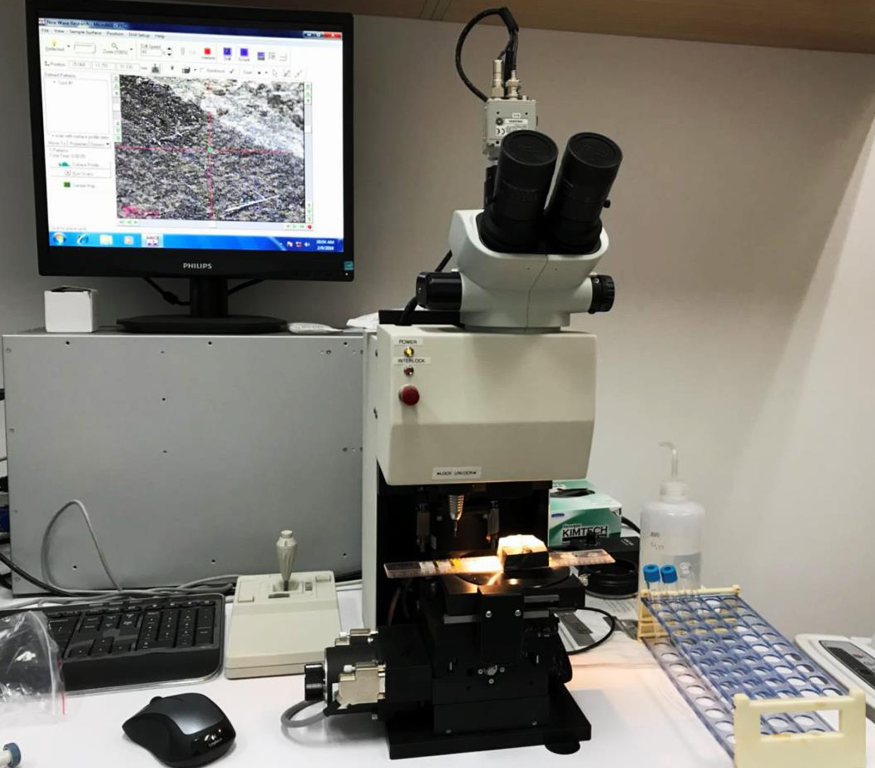
Figure S1. Micro drill
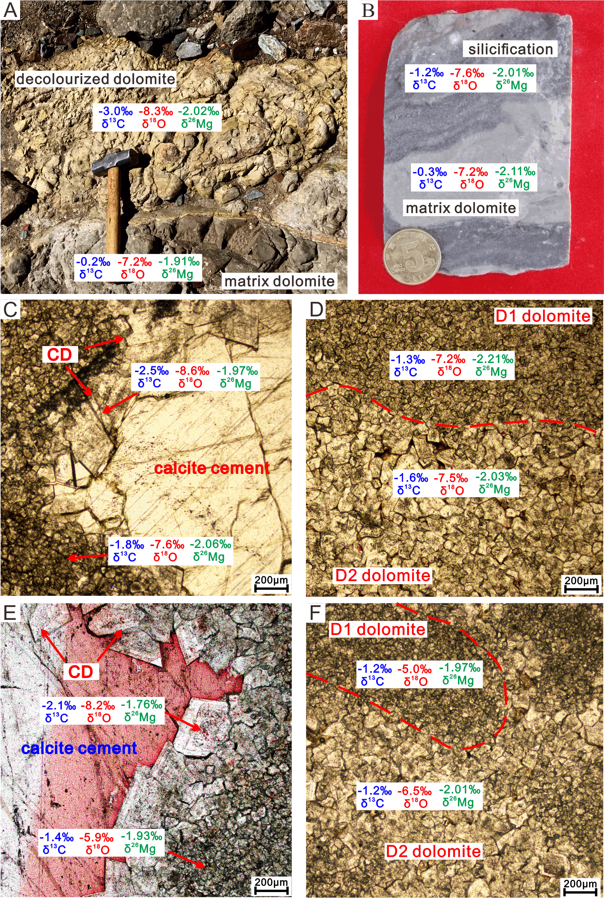
Figure S2. A comparison of C-O-Mg isotope values in different types of dolomite that was exacted by micro drill.
(A) Hydrothermal fluid decolorized the matrix dolomite in the fracture (sample AO-2), Aksu outcrop; (B) Silication bands in hand sample, YB5, 6842.68m; (C) Dissolution pore filled by saddle dolomite cement and block calcite, TS2, 6692.57m, transmitted light; (D) Inhomogenous recrystallization, the bulk dolostone was mainly composed by D1 and D2 dolomite jointly, TS2, 6693.2m, transmitted light; (E); Dissolution pore filled by saddle dolomite cement and block calcite, TS2, 6551.7m, transmitted light; (F) Inhomogenous recrystallization, dolostone was composed by D1 and D2 dolomite, TS2, 6552.85m, transmitted light.

